CST8912 – Lab 4 - Week 5

Rae Ehret, 040907812

# Create resource group and then Azure SQL Database.

In this step we create the resource group cst8912-demo.

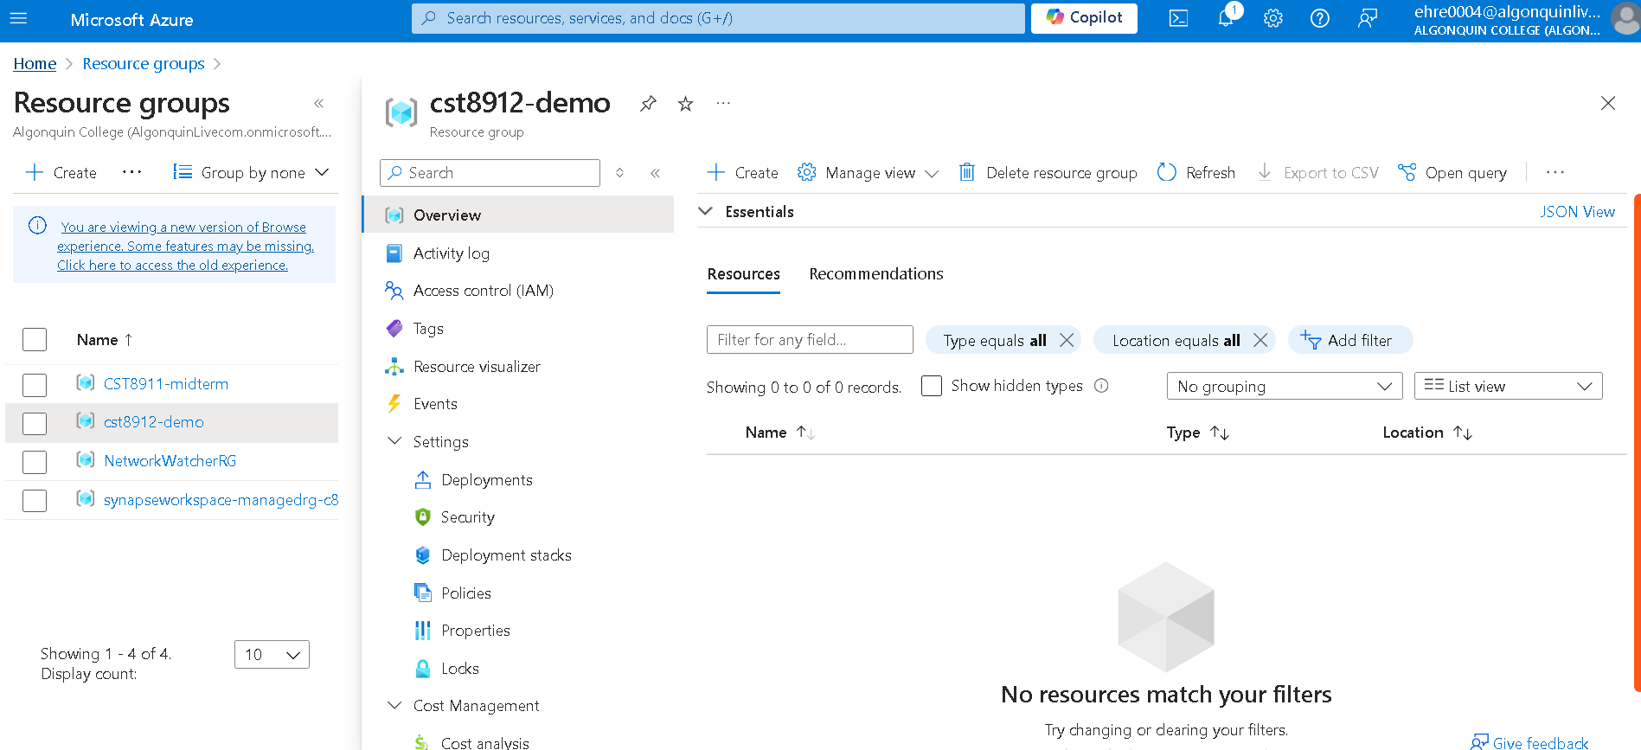

Next, in this resource group we create the Azure SQL database for Canada central region. For SQL databases in SQL deployment options, it should be a single database.

# Enter values into Create SQL Database page 1

Under Database name, create new and fill in the fields like below (Canada central, SQL authentication, …). My name is Rachel Mae, so my username is rachelmae. Remember the password you put in.

# Networking: making sure we can access our database

On the Create SQL Database page, select Next: Networking to reach the Network connectivity section. Select here “Public endpoint”. For Firewall rules section select “Yes” to allow access to database server from Azure services and our current client IP address.

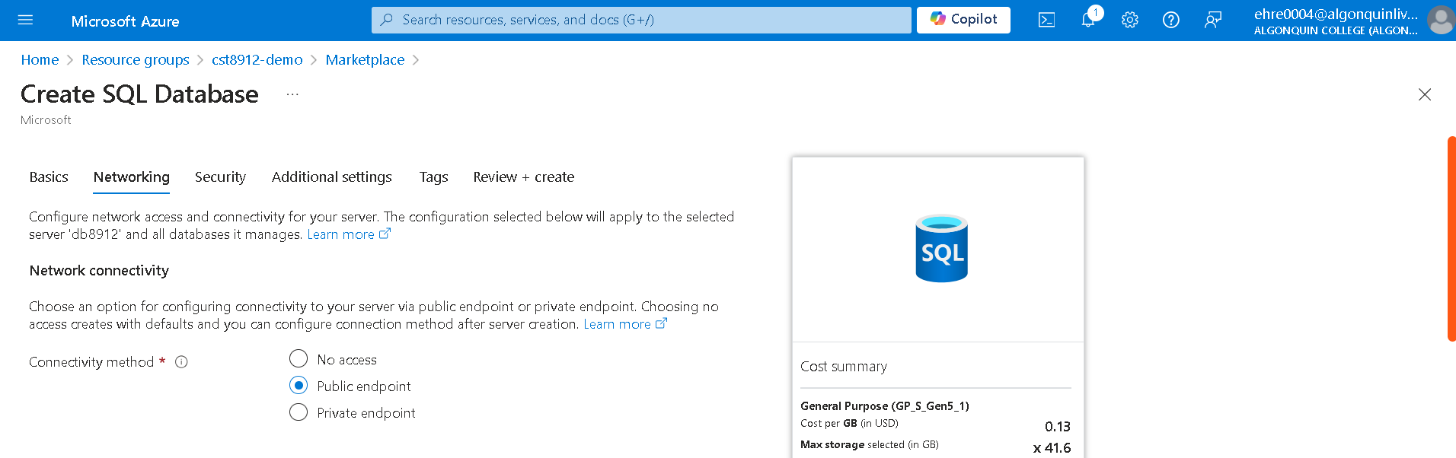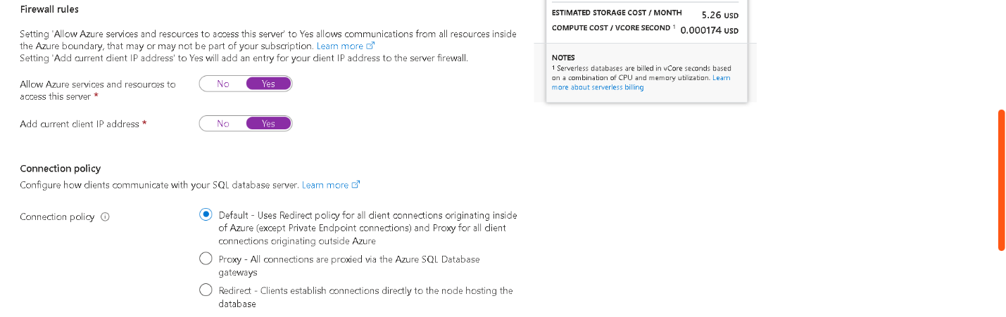

# Security: Not now

Going to the next page (Security), make sure Microsoft Defender for SQL option is “Not Now”.

# Additional Settings: Use existing data (Sample)

Selecting Next: Additional Settings bring us to a page with other settings for our database. Set the “Use existing data” option to Sample. This should create sample data to populate our database with.

# Create the database

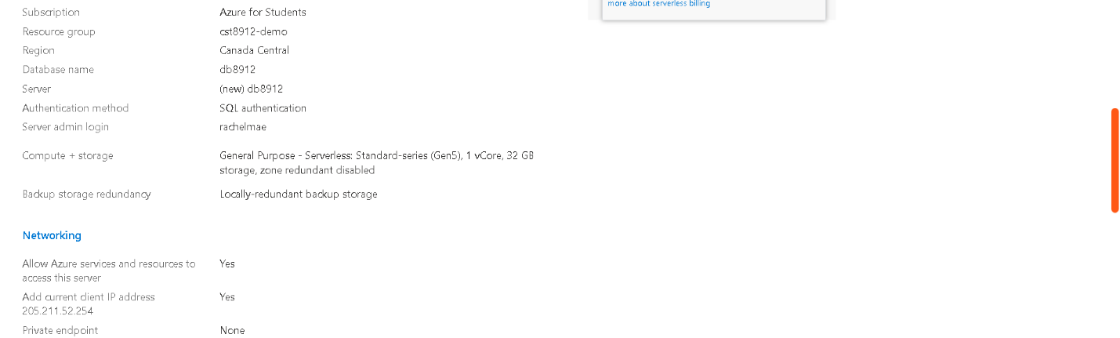

# Query editor (preview)

After your database finishes deploying, select Query editor (preview) in the pane to the left.

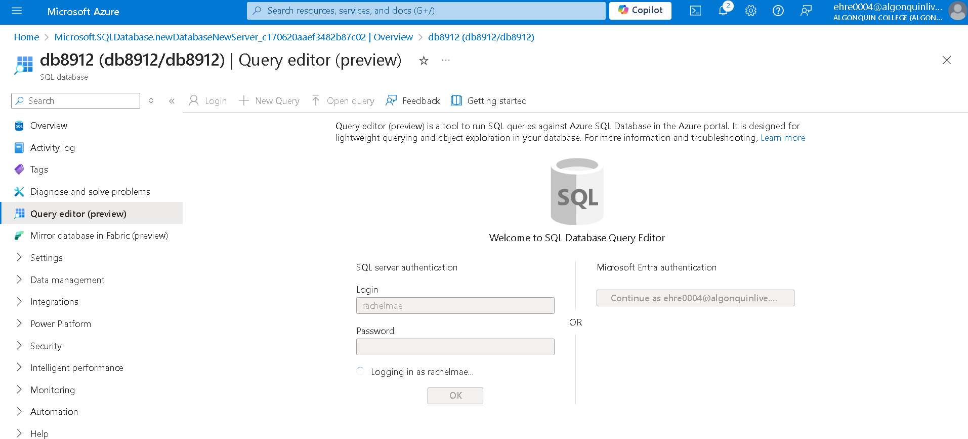

Login using your username and password from a previous step.

# Expand the tables folder to see tables

# Query the database

Once the query editor opens, try the following queries on the sample data:

SELECT ProductID, Name, ListPrice, ProductCategoryID   
FROM SalesLT.Product;

SELECT p.ProductID, p.Name AS ProductName,  
 c.Name AS Category, p.ListPrice  
FROM SalesLT.Product AS p  
JOIN [SalesLT].[ProductCategory] AS c  
 ON p.ProductCategoryID = c.ProductCategoryID;

# Create an Azure storage account

Use the following settings, and keep all other settings default:

Subscription: Azure for Students  
Resource group: cst8912-demo  
Instance details  
 Storage account name: demo8912  
 Region: Canada central  
 Performance: Standard  
 Redundancy: Locally-redundant storage

# Create a container in storage account

Name the container “productdata8912”.

# Create azure data factory

Create a new resource in your resource group. Search for “Azure data factory”, keep git configuration, networking, advanced as default, and with the following configuration:

Subscription: Azure for Students  
Resource group: cst8912-demo

**Instance details**Name: demodb8912  
Region: Canada Central  
Version: V2

# Launch azure data factory studio

# Home page > ingest data

On the home page, select “ingest data”.

# Task type

Select for task type “built in copy task” and for task cadence “run once now”.

# Source type

Select for source type “Azure SQL database”, and for connection choose “new connection” with the following configuration. Test connection.

If testing the connection doesn’t work, instead of navigating the dropdowns from your subscription to choose your DB, try pasting the database string manually (you can find the db server string on its page under your resource group, e.g., db8912/db8912 for this example. There can be trouble if the names are similar.A screenshot of a computer

# Choose “SalesLT.Product”

# Destination type: Blob Storage

Click “Next”. Select “Azure Blob Storage” as the destination type.

# Make a new connection to blog storage account

Make a new connection with the settings set to your storage account (demo8912).

Once a connection is created, choose the folder path (your container, e.g., productdata8912), and then enter “product” as the file name.

# Choose configuration for copying data

The defaults should be “Delimited Text”, “Comma (,)”, “Default …”, and “Add header to file”. This is fine for a csv file.

# Review, finish pipeline, and check container for file

# Delete all resources from this lab

